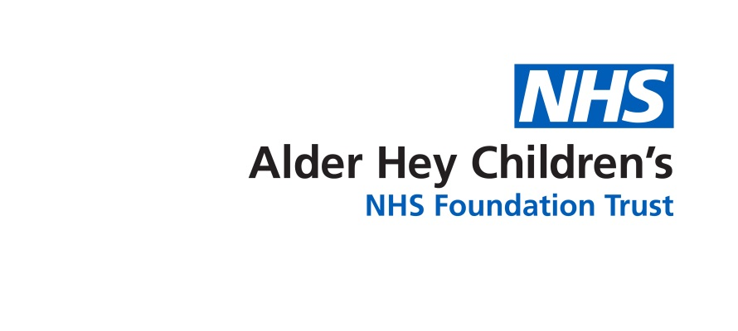

Inherited Bleeding Disorders Team

**Parents/Carer Support**

Information for Parents and Carers

**Introduction**

This leaflet aims to provide you with general information about support for you as the carer of a child with an Inherited Bleeding Disorder. If you are ever worried about your child please contact your team or take your child to the Accident and Emergency Department.

**Information for carers- all about you**

Your child has been diagnosed with an inherited bleeding disorder.

This diagnosis might have been expected, known to be a possibility or unexpected. Finding out about your child’s diagnosis can leave you with a mix of emotions and wondering about treatments and day to day practicalities. Sometimes these feelings and thoughts don’t hit you as soon as your child is diagnosed but appear, sometimes unexpectedly at a later date.

The nurse specialists are here to provide you with support, advice, information, education and training when you need it.

**Support**

Shortly after diagnosis, should you wish, we can put you in contact with another family whose child has the same condition. It can be helpful to talk to other families to find out about their experiences and how they manage their child’s condition at home.

The nurse specialists are happy to arrange a time to see you outside of your child’s routine clinic appointments.

Ideally we would have planned informal family events and we hope to continue with these soon.

The Haemophilia Society <https://haemophilia.org.uk> can provide further information and support. They run weekends away for families with children who have been diagnosed with an Inherited Bleeding Disorder as well as other activities.

Often families find support through social media, such as the Haemophilia Society Facebook site.

**Practical support**

There may be a time where you are unable to treat your child due to illness, ongoing poor health, or you simply need a break. If this happens please contact the nurse specialists. We can talk together about the best way for us to provide support.

Each year we will send you a newsletter with service and treatment developments and updates as well as activities scheduled for education, training and support.

We ask you for feedback on the service with an annual questionnaire. The results from the questionnaire help us to provide the service you want.

At times you may need more than we can provide and we can refer you on to other services including:

* Genetic service for information, testing or genetic counselling
* Adult haematology service if you are having any bleeding problems
* Psychology services
* Any other services you feel will help you

**Contact Information** Haematology Nurses 8.00am-5.00pm 0151 252 5070 with answer machine. Queries will be reviewed by the end of the next working day.

**Sharon Thind**: 07584 234 526 [sharon.thind@alderhey.nhs.uk](mailto:sharon.thind@alderhey.nhs.uk)



This leaflet only gives general information. You must always discuss the individual treatment of your child with the appropriate member of staff. Do not rely on this leaflet alone for information about your child’s treatment.

This information can be made available in other languages and formats if requested.

Alder Hey Children’s NHS Foundation Trust

Alder Hey

Eaton Road

****Liverpool

L12 2AP



Tel: 0151 228 4811

[www.alderhey.nhs.uk](http://www.alderhey.nhs.uk)

**© Alder Hey Review Date: 01/02/2028 PIAG: 192**