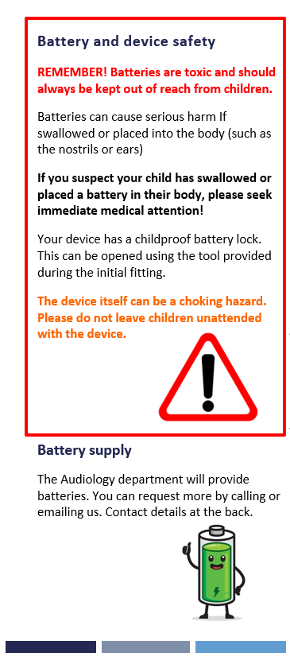

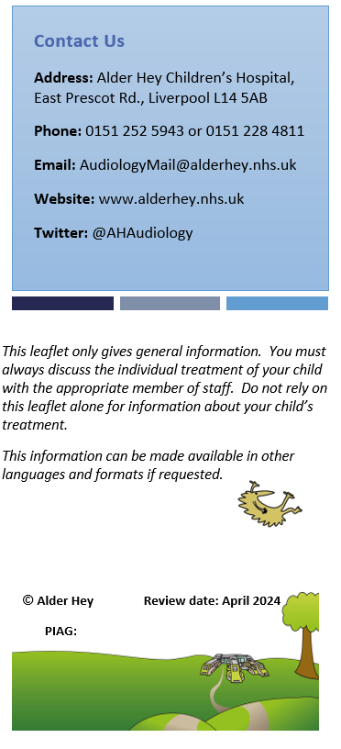

This leaflet only gives general information. You must always discuss the individual treatment of your child with the appropriate member of staff. Do not rely on this leaflet alone for information about your child’s treatment.
This information can be made available in other languages and formats if requested.
Alder Hey Children’s NHS Foundation Trust
Eaton Road

Liverpool
L12 2AP
Tel: 0151 228 4811
www.alderhey.nhs.uk
© Alder Hey
Review Date: August 2026
PIAG: 493


