

ENT and Audiology services

**Implantable acoustic devices (IADs)**

Information for patients, families and carers

**IADs are appropriate for certain types of hearing loss. Similar to conventional hearing aids, they stimulate the cochlea (hearing organ). Unlike conventional hearing aids, they do not need the outer or middle part of the ear to be working normally.**

**This information leaflet describes the types of IAD’s available at Alder Hey.**

**How IADs work**

Instead of sending sound through the ear canal like conventional hearing aids, IADs transmit sounds through the skull and middle ear bones to the hearing organ.

****They are usually suggested for people who cannot wear conventional hearing aids due to their ear not developing in the usual way,or have a certain type of hearing loss.

**There are three types of IADs available at Alder Hey:**

1. Percutaneous bone conduction implant (BCI).
2. Active transcutaneous BCI.
3. Middle ear implant.

Each type has it’s own advantages and disadvantages. Not everyone is suitable for each type of device.

Your child’s ENT surgeon or Audiologist will discuss the options that are suitable for your child.

**Initial assessment**

Different hearing tests, examination and history will guide the clinicians on whether your child may be a suitable candidate.

If suitable, you are initially offered a choice of devices then a trial arranged with your preferred device. This usually last 4-6 weeks.

You will then be reviewed and, if suitable, given the option if you would like more information about surgical options.

Below, we explain each of the different IADs available.

1. **Percutaneous bone conduction implant**

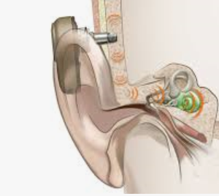

An abutment is visible through the skin on the scalp, attached to the sound processor on the outside and the skull on the inside which sends vibrations through the skull.

Suitable for single sided deafness, conductive and mixed hearing losses.

* Better hearing outcomes
* Able to have certain MRI scans
* Abutment site requires daily cleaning and can become infected
* Not able to use while swimming

a better hearing outcomes

*Diagram of percutaneous BCI. Image courtesy of*

*Oticon Medical, 2021*

**2. Active transcutaneous bone conduction implant**

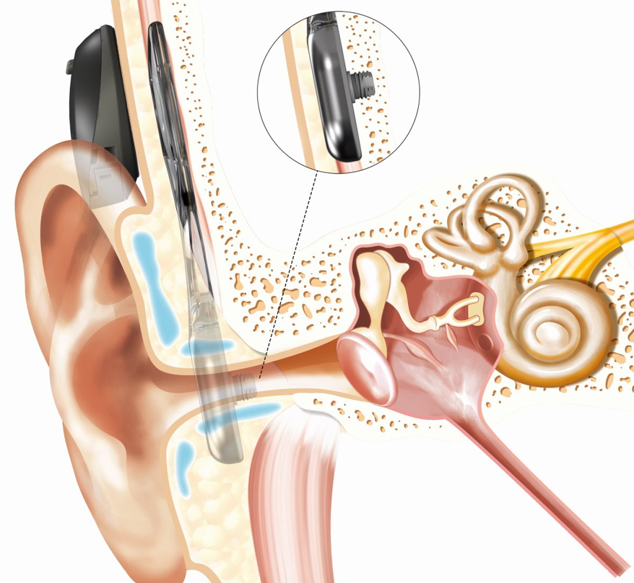

An implanted magnet sits under the skin attached to an implant that sends vibrations through the skull. The sound processor is held on the outside of the skin with a magnet and send signal through the scalp.

Suitable for single sided deafness, conductive and mixed hearing losses.

* Better hearing outcomes
* Implant under the skin, reducing the risk of complications such as skin irritation
* Processor held on by magnet, available in different strengths
* Lower risk of acoustic feedback
* Able to swim whilst wearing processor
* MRI scans require precautions
* Implant can be visible under the skin

*Diagram of Osia active transcutaneous BCI. Image courtesy of Cochlear, 2022*

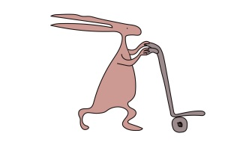

1. **Middle ear implant**

This sound processor works in a similar way to an active transcutaneous BCI with a magnet. It sends sounds directly to the bones in the middle ear rather than the skull.

Suitable for mixed and certain sensorineural hearing losses.

* Implant under the skin, reducing the risk of complications such as skin irritation
* No part of implant protruding through skin; when device not worn, no parts to see
* Processor held on by magnet, available in different strengths
* Lower risk of acoustic feedback
* MRI scans require precautions
* Surgery is more complex

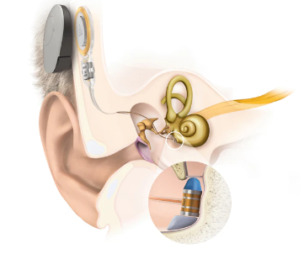

*Diagram Vibrant Soundbridge middle ear implant. Image courtesy of Medel, 2022*

**Surgery**

The ENT surgeon will discuss what to expect before and on the day of your surgery. We encourage you to ask any questions and ask you to sign a consent form to give your permission.

The operation will be carried out under general anaesthetic.

Your child’s hair may need to be shaved and following surgery they will have either a bandage or protective cover (healing cap) over the site.

Rarely some operations are carried out over two stages.

**Are there any risks?**

All surgery and anaesthesia carries risk, but we do everything we can to minimise it. The risk of anaesthetic will depend on your child’s medical conditions, but an anaesthetist monitors their progress during surgery very closely.

All of these types of surgery carry the risk of bleeding or infection. Blood loss during this type of surgery is usually minimal, and we may give antibiotics to help reduce the risk of infection. Infections may require implants to be removed. The implants can become loose due to infection or trauma.

Specific to middle ear implants, there are added risks of causing a permanent hearing loss or damaging the nerve that moves the face.

There is a small risk that your child may not feel they get enough hearing benefit from the IAD.

**Going home after surgery**

If your child recovers well they will be able to go home on the same day.

You will be given more information before you leave the hospital on how to monitor your child and look after the operation site

**What happens after surgery?**

You will be asked to keep the dressing or healing cap on for around 7 days and not get the site wet. After 7 days you will come back to see the ENT nurse to check your site.

Around 6 weeks after surgery, your device will then be ‘loaded’ (the hearing device will be activated and you are shown how to wear with your surgical implant).

**Contact details:**

Audiology: [audiologymail@alderhey.nhs.uk](mailto:audiologymail@alderhey.nhs.uk) or

0151 252 5943

ENT: 0151 228 4811 ext 3757 or 0151 252 2506

Useful websites:

[www.cochlear.com/uk](http://www.cochlear.com/uk)

[www.oticonmedical.com/uk](http://www.oticonmedical.com/uk)

[www.medel.com/uk](http://www.medel.com/uk)

[www.ndcs.org.uk](http://www.ndcs.org.uk/)

This leaflet only gives general information. You must always discuss the individual treatment of your child with the appropriate member of staff. Do not rely on this leaflet alone for information about your child’s treatment.

This information can be made available in other languages and formats if requested.

Alder Hey Children’s NHS Foundation Trust

Alder Hey

Eaton Road

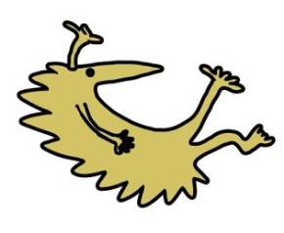Liverpool

L12 2AP



Tel: 0151 228 4811

[www.alderhey.nhs.uk](http://www.alderhey.nhs.uk)

**© Alder Hey Review Date: August 2026 PIAG: 485**