

Community Speech and Language Therapy

**Attention and Listening**

Information for parents/carers and settings



**Some children find attending and listening to people difficult. These children may get confused, guess at the subject being discussed or tune out altogether. To help children with their listening and attention you can:**

* Reduce distractions including background noise
* Use play materials suitable to the child’s age and interests
* Let the child lead the play
* If the child is distracted encourage them to return to the activity once for a few seconds. Reward any return to the activity however brief.
* Give the child lots of praise and encouragement
* Ensure you are positioned so that the child can see your hands and face.
* Encourage your child to listen to different everyday sounds e.g., aeroplanes, animals, the door knocking.
* Gain your child’s attention by calling their name or touching them before talking
* Use visual prompts and cues such as gesture, pointing, objects, pictures, etc to help maintain attention.

**Activities that help develop attention and listening skills: (pick the ones you think your child will respond to)**

**Individual activities:**

* **Sound matching** – you could use musical instruments or make some sound shakers. Make a sound while the child looks away. They must find the instrument/shaker that makes the same sound. (As the child improves, try making 2 or 3 sounds and see if they can copy these in the correct order)
* **Shopping game/posting** – child must find and buy/post, 1, 2 or 3 named items. You could use objects or pictures.
* **Listening to the** **environment** – (a) child sits still and listens for 30 seconds. They must then recall the sounds they have heard. (b) go for a walk. Child must identify any sound they hear then recall as many as they can when they get back.
* **Listening and identifying everyday sounds** - The child listens to a recording of everyday sounds and tries to identify what it is e.g., a dog barking.
* **Selective listening tasks** – child is told a word they must listen for. Adult then either says individual words or tells a simple story. Each time the target word is mentioned, the child must put a brick on a tower.
* **Run and touch -** Say “run to the …”. Add one item into the gap (e.g., “run to the tree”) and once the child is successfully able to do this then add two (e.g. run to the tree and then the gate).
* **Silly sentences** – describe a picture using a simple sentence but use one obviously incorrect word. The child must identify and correct your mistake.
* **Silly stories -** Warn the child that you are going to read a book and make mistakes and they must spot them. Read a familiar story and make errors. How many can the child spot?
* **Hide and seek objects** - Hide up to eight objects around the room/outside. Ask the child to find one item. When they can do this, ask them to find two.
* **Go!** - Give instructions but the child must wait until you say “go” to carry them out. Gradually make the instructions harder by adding more parts and increasing the time interval between the instruction and “go”.



**Group activities:**

* **Ball game** – children sit in a circle and the ball is thrown between them. As name is called, the child has to look and be ready to catch the ball.
* **Stop and go games** – child has to perform an action in response to sound/music e.g., musical statues, musical chairs, sleeping lions.
* **Sound lotto** - child matches the sound heard to a picture, e.g., animal noises to animals.
* **Responding to stories** – children have to do something in response to a word heard in a story e.g., meow, when they hear a ‘cat’, wave, when they hear their name etc.
* **Clapping rhythms** (children listen to you and then copy)
* **Do as I say** – child follows spoken commands to perform activities, e.g., John, point to your feet. Sarah, clap your hands. At a much more advanced level, play Simon says.
* **I spy** (by giving beginning sound or by giving a visual clue i.e., “something that is green”)
* **Run and touch** - Say “run to the …”. Add one item into the gap (e.g., “run to the tree”) and once the child is successfully able to do this then add two (e.g., run to the tree and then the gate)

Schools can find further advice and ideas in the Primary School Toolkit: share appropriate ideas and advice with the child’s Parents/Carers so they can support the child at home too.

**Sefton (0151 247 6109) Liverpool (0151 295 3990)**

[**Childrensslt@alderhey.nhs.uk**](mailto:Childrensslt@alderhey.nhs.uk)

[Speech and language therapy - Alder Hey Children's Hospital Trust](https://www.alderhey.nhs.uk/services/speech-and-language-therapy/)

(click this link or type into search engine)

This leaflet only gives general information. You must always discuss the individual treatment of your child with the appropriate member of staff. Do not rely on this leaflet alone for information about your child’s treatment.

This information can be made available in other languages and formats if requested.

Alder Hey Children’s NHS Foundation Trust

Alder Hey

Eaton Road

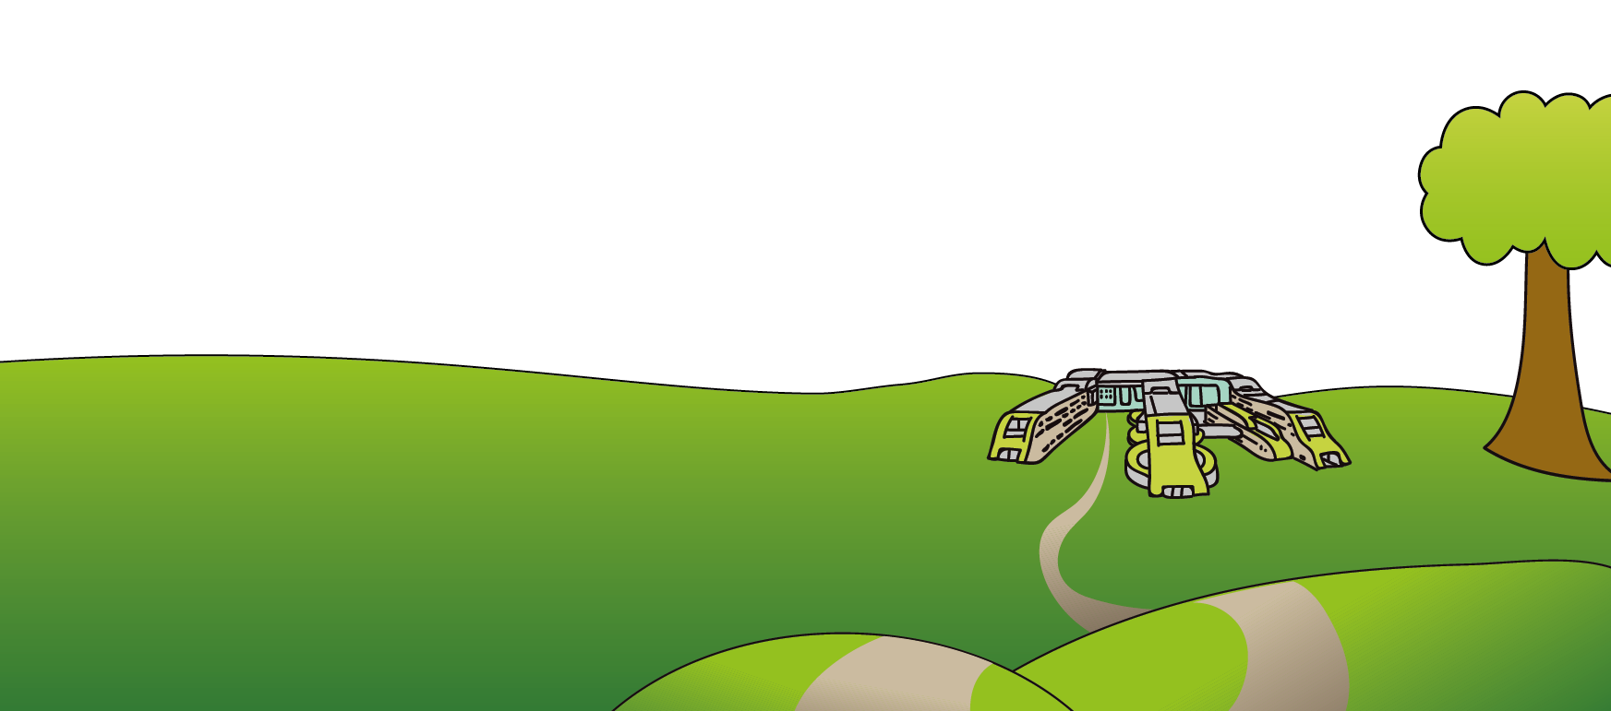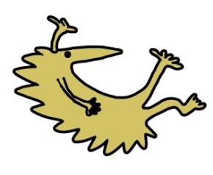Liverpool

L12 2AP

Tel: 0151 228 4811

[www.alderhey.nhs.uk](http://www.alderhey.nhs.uk)

**© Alder Hey Review Date: March 2028 PIAG: 595**