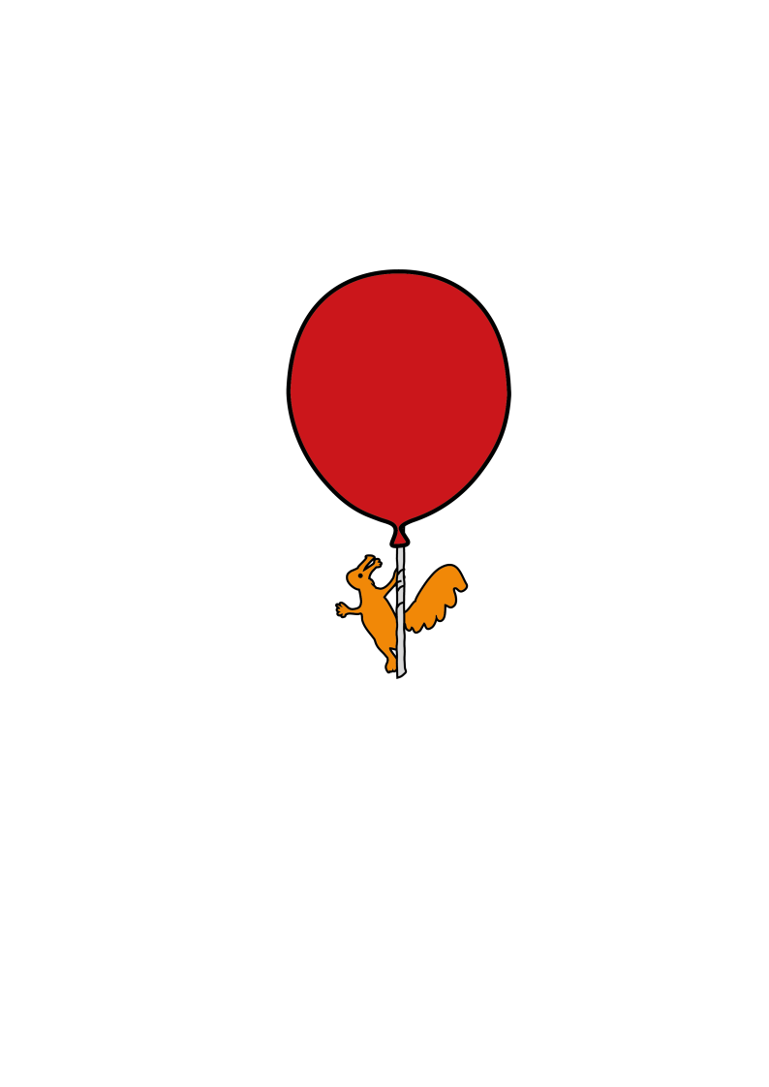

Community Speech and Language Therapy

**Objects of Reference**

**Information for families and settings**

Objects of reference are objects which have special meanings for your child. If your child cannot hear or understand what you are telling them or cannot see what is happening, objects give an alternative way of communicating this information to your child. Objects can “stand for something” in the same way as words or signs do and are a way of supporting early communication and understanding.

**Why use them?**

There are several reasons why a child might benefit from using objects:

Understanding - Once an object has been shown to your child again and again in the right activity/place your child may start to link the word with the object. Over time this may help them understand the word.

Multisensory skills– encourages children to use all their available senses (touch, smell, sound, sight) to explore objects. This is particularly useful for children who are tactile defensive (very sensitive to touch)

Object recognition – children learn to tell objects apart

Association - develops the ability to associate objects with a specific activity/routine/room.

Expression - some children may quickly learn the meaning of the objects and use them to give us a message. This could be by their reaction when given an object (they may pull a face or refuse to take an object if they know it means an activity/place they don’t like), or by choosing between objects to show what they want.

Behaviour – this can help reduce fear, frustration or worry about what will happen next or where they are going.

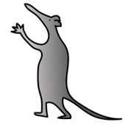

**How to use Objects of Reference**

Choose objects which are only used in a certain activity/routine. For example, use a favourite toy to show playtime, but only if the child would not have the toy at other times such as to cuddle in bed.

Try and keep the objects in a bag/box when they are not in use so they are easily accessible.

Before taking the child to an activity, give them the object to hold/touch or show them and carry it for them. Allow them time to explore it and talk to them about what it means. If the object makes a noise, help the child make the noise.

After the activity has finished put the object away in the box. Draw the child’s attention to the fact that the object has gone and the activity has finished, for example, ‘drink finished’.

Try to use real objects at first, you may move on to the use of some miniature versions (such as a toy plate) or objects that are less obvious (for example, a star for song time).

Use the same object and word each time and use them every time you do the routine or activity, even if the child doesn’t understand straight away.

**Some suggestions of the type of objects that can be used:**

|  |  |
| --- | --- |
| **PLACE/ ACTIVITY** | **OBJECT** |
| Drink | Cup |
| Mealtimes | Spoon |
| Bedtime | Pyjamas/teddy |
| Going out | Coat |
| Playtime | Ball/rattle/favourite toy |
| Music | Old CD/ headphones |
| Nappy changing | Nappy |
| Going in the car | Old key |



  

This leaflet only gives general information. You must always discuss the individual treatment of your child with the appropriate member of staff. Do not rely on this leaflet alone for information about your child’s treatment.

This information can be made available in other languages and formats if requested.

Alder Hey Children’s NHS Foundation Trust

Alder Hey

Eaton Road

Liverpool

L12 2AP

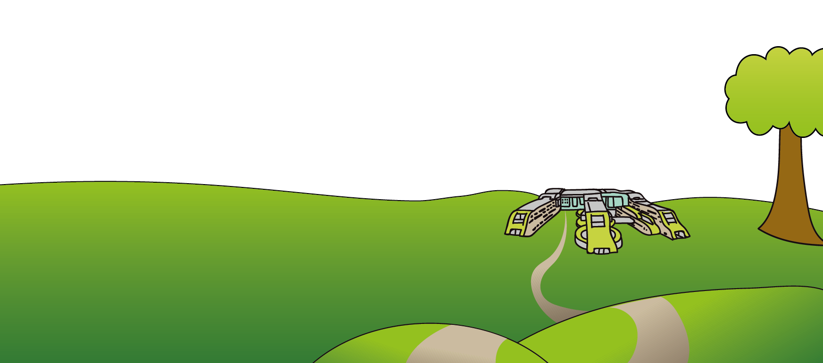

Tel: 0151 228 4811

[www.alderhey.nhs.uk](http://www.alderhey.nhs.uk)

**© Alder Hey Review Date: February 2028 PIAG: 588**