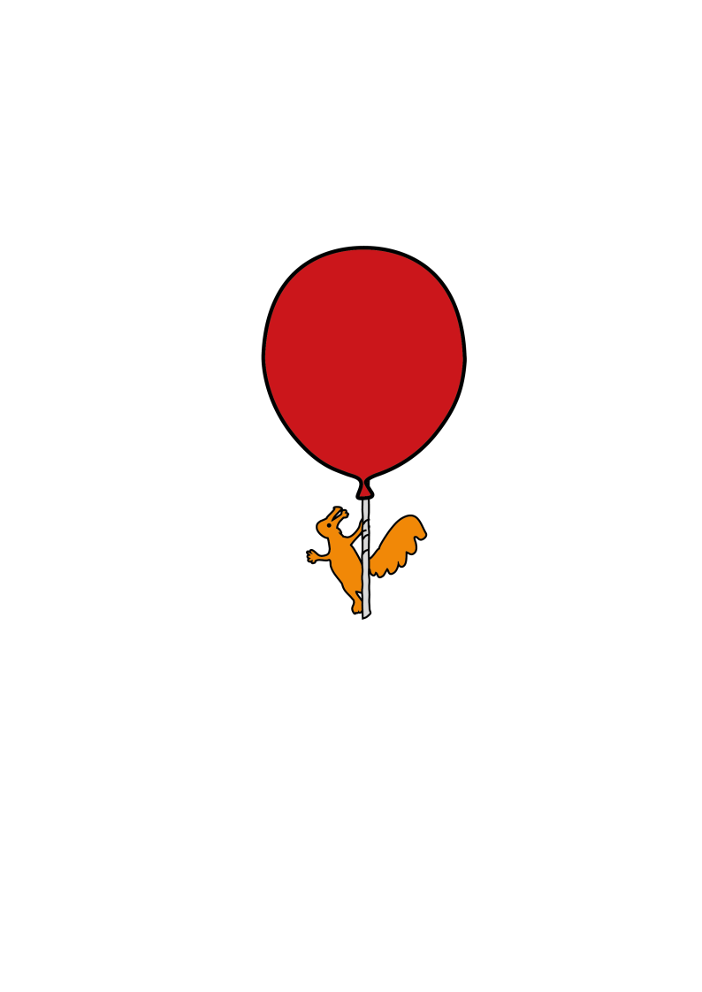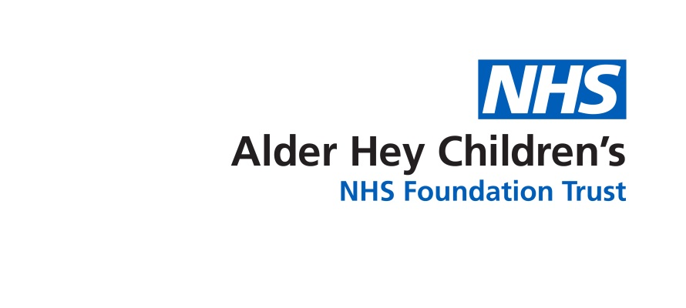

**Paediatric Surgery**

**Rectal Biopsy**

**Information for Parents and Carers**

**Introduction**

**What is Hirschsprung’s Disease?**

Hirschsprung’s disease is a rare condition which can make if difficult for babies and children to poo. It is caused by the nerves at the end of the bowel not developing. Hirschsprung’s Disease is usually diagnosed shortly after birth but sometimes can be diagnosed in older children.

**How is Hirschsprung’s Disease diagnosed?**

The best way to diagnose Hirschsprung’s Disease is to look at the bowel under the microscope to see whether nerve cells are there or not. If there are no nerve cells (called ganglion cells) then Hirschsprung’s disease can be diagnosed. To look at the bowel under the microscope a baby or child has to have a rectal biopsy.

**What is a Rectal biopsy?**

A rectal biopsy is a procedure where a small sample of tissue is taken from the end of the bowel close to the bottom. There are two different ways to do a rectal biopy. Babies and very young children can have a suction rectal biopsy which is undertaken when they are awake; this is very well tolerated and not painful. Older children need a larger biopsy called a strip rectal biopsy, which is taken while they are asleep in theatre.

**Suction rectal biopsy**

During a suction rectal biopsy 2-3 very tiny samples of bowel are taken from the lowest part of the bowel, called the rectum. This is done by placing a small instrument into the bottom and to take the samples. These samples of bowel are sent to the laboratory to be looked at under the microscope.

A Full Blood Count (FBC) test may be needed to check your child’s haemoglobin and platelet count are within normal range before the procedure.

**Strip rectal biopsy**

A strip rectal biopsy is taken in older children when a suction rectal biopsy is less good at getting enough tissue to give an answer about the nerve cells. This is done whist the child is asleep. Some stitches are placed inside the bottom to close the area where the biopsy is taken from.

**What are the benefits of a rectal biopsy?**

A rectal biopsy will diagnose if a child has Hirschsprung’s Disease.

**What are the risks of a rectal biopsy?**

Rectal biopsy is a simple and safe procedure, however, there are some risks.

These include:

Insufficient or inconclusive sample. This is the most common risk of a rectal biopsy and occurs in approximately 1 in 50 samples. If this occurs the biopsy will need to be repeated.

Bleeding. Most children will have a little bit of bleeding after the procedure but this usually settles very quickly. Less than 1 in 100 children need a further procedure to control bleeding after a rectal biopsy. It’s not unusual to have a further few specks of blood 7-10 days after the procedure when the clot that has dried comes off.

A small hole being made in the rectum (perforation). This is a very rare complication but if it were to occur then the baby or child may need a further operation to treat this.

**After the procedure**

The nurse looking after the child will observe them for up to 4 hours, watching for signs of rectal bleeding.

Pain medicine can be given if the child is in pain/discomfort.

Children cannot have any rectal therapy including suppositories, enemas, washouts for 24 hours after a suction rectal biopsy and 48 hours after a strip rectal biopsy.

If a child experiences any fresh ongoing rectal bleeding they need to be reviewed urgently at their local Emergency Department.

**Follow up**

Families will be informed of the rectal biopsy result either in a follow-up appointment,or by the ward team if the child is still in hospital.

**Contact telephone numbers:**

Ward 3A (Surgical ward) – 0151 252 5416

Lower GI secretaries – 0151 293 3693/0151 252 5272



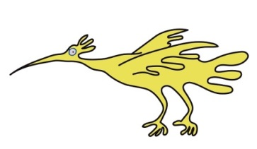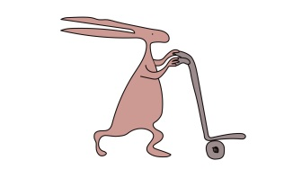This leaflet only gives general information. You must always discuss the individual treatment of your child with the appropriate member of staff. Do not rely on this leaflet alone for information about your child’s treatment.

This information can be made available in other languages and formats if requested.

Alder Hey Children’s NHS Foundation Trust

Alder Hey

Eaton Road

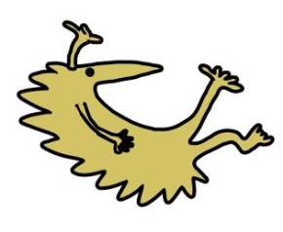Liverpool

L12 2AP

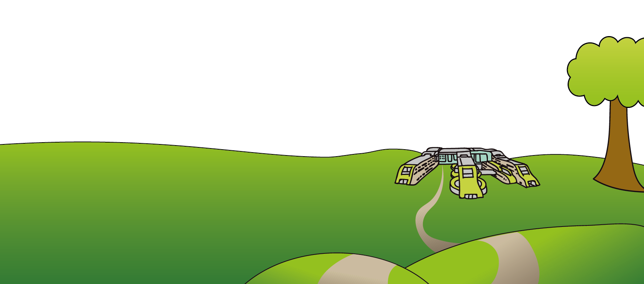

Tel: 0151 228 4811

[www.alderhey.nhs.uk](http://www.alderhey.nhs.uk)

**© Alder Hey Review Date: February 2028 PIAG: 584**