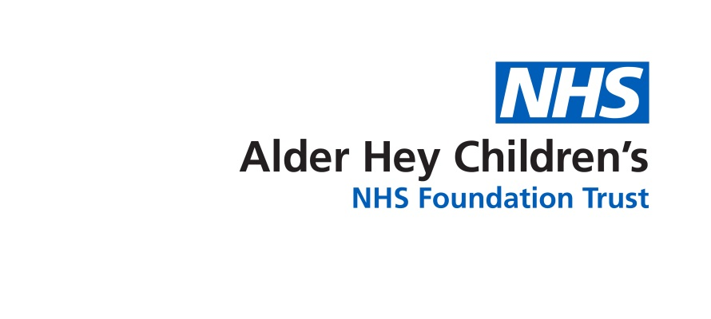

Speech and Language Therapy

**Secondary Mainstream Classroom: Recommendations to Support Language Skills for school staff**

**Auditory Memory and Understanding Language:**

* Make sure the **young person is positioned well**, if possible close enough to you to ensure that they are paying attention; away from potential distractions; able to see you, the board and any visual materials clearly. The young person may choose to sit on the fringe and need extra encouragement to be involved.
* Make sure the **young person is aware of the aim of each lesson**, explain this at the beginning and put it on the board [use a picture/symbol/diagram if that is more appropriate than the written word alone].
* It may also help the young person to **know what’s coming next** within each lesson. Write the key parts of the lesson on the board or use symbols/simple diagrams/visual timetables for the non-reader.



* Wherever possible, follow the principle **KISS** [**K**eep **I**t **S**hort and **S**imple]. The young person may easily be “over-loaded”. Reduce your language input in terms of sentence length, complexity of sentence and level of vocabulary. A lot of verbal input may feel like a barrage of words. (Ref: Hanen)
* Repetition and re-phrasing too quickly can interfere with the young person’s processing. **Try to wait**; only repeat when it is clear that they have not understood. The first repetition should use the same words; only change the wording if the young person still appears not to understand.
* **Try to do one thing at a time**, young people with auditory memory and understanding language needs may find it difficult to attend to more than one thing, e.g. **either** writing **or** looking in books **or** listening. Flag up changes in the activity, making it clear what you are expecting the young person to attend to at each time.
* Support verbal language as far as possible with **visual materials**: use gesture, pictures, real objects and symbols including the written word to facilitate their understanding of key learning points. Spoken words disappear but visuals are permanent.
* Reinforce good listening skills and help the young person to sift information for key points by **flagging up in advance what it is that they need to listen out for**, eg “after I’ve talked about… [general topic] I’m going to ask you about these things… [specific points of information]”
* Provide the young person with a **written list of questions** you will ask the class before the input (e.g watching a video, reading a text) is carried out so that processing time is provided.
* Break down instructions into manageable chunks, using a clear sequence, “**first…then…next…last…**” [The young person may only be able to retain two actions required or possibly only one; be aware of these limitations].
* Regularly **check the young person’s understanding** of what they have been asked to do by asking them to explain or demonstrate. It is not enough to only ask, “does that make sense?” as most will respond with “yes”, even if this not true. If the young person does not feel confident enough to say when they do not understand, **develop an agreed ‘secret code’** so they can communicate this. E.g when the young person places their rubber at the top of the desk, this signals that they require help.

**Inferential Language Skills:**

Young people who have language difficulties, are Autistic and/or trauma-experienced, may struggle to answer questions which require inference skills such as:

* Predicting what might happen next.
* Commenting on how someone else might feel or what they would say in a situation.
* “Why” questions.
* Justification questions, e.g “How do you know…”
* Problem solving, e.g “What could you do instead next time?”.

The adults around the young person should be aware of this and support them by:

* Asking more **concrete questions** (e.g naming and describing) than inferential questions.
* If the young person is struggling to answer a question, use **forced alternatives**. E.g “Why did the girl lie to the boy? Is it because she wanted to be mean or to be kind?”
* If the young person is still finding it hard to answer a question you can **model** the answer for them. E.g. “I think the girl lied to the boy because she didn’t want to hurt his feelings by being honest”.
* If the young person presents with **behaviours which challenge**, be aware they are unlikely to be able to answer inferential questions (e.g “Why did you do that?”) and especially when dysregulated. **Reduce language and ask questions with modelling once the young person is regulated.**



**Vocabulary Skills:**

* Important vocabulary to target for young people with vocabulary difficulties include
  + those that are **essential for learning a particular topic** (e.g photosynthesis, oxygen)
  + and **instruction words** (e.g analyse, discuss).
* To consolidate vocabulary understanding, students need to have *multiple* opportunities to **hear** the new word, **see** in writing, **say** it and **write** the word by themselves. This can be done in various ways:
* Using visuals such as word webs, word walls, drawing a picture of the new word.
* Explore synonyms of the word.
* Word of the Week for instruction words (e.g analyse, discuss).
* Incorporate new words into a range of classroom activities, e.g activity instructions, worksheets, group discussions.

**Grammar Skills:**

* If a young person uses incorrect grammar or produces words in the wrong order and you know what they had intended to say, model back the correct version to them. E.g if a young person’s answer was “The man catched the bus”, you would respond, “Yes, well done. The man *caught* the bus”.

**Narrative (Explaining) Skills:**

* Give the young person plenty of time to plan a response & say what they mean by **counting to 10 seconds in your head after asking a question**. It can feel awkward to wait for this long, but it is necessary to provide them with processing time.
* **Encourage the student to self-monitor** when their explanations do not make sense. E.g Initially acknowledge the information that you understood, “Ok, so you went shopping on Saturday”. Then suggest things such as “but I’m sorry, I don’t quite understand the bit about the bus. Could you change it to help me understand?”. Allow the student to rephrase and give praise. This is encouraging the student to take responsibility for their communication and to know when the listener has not understood and what they could do to remedy this.
* Ask the student to **draw out an event** in a ‘comic-strip’ style if they are struggling to clearly explain it, e.g social situation, play, reading text.

Schools can find further advice and ideas in the Secondary School Toolkit (coming soon): share appropriate ideas and advice with the child’s Parents/Carers so they can support the child at home too.

**Signposting to Other Services:**

* It is recommended that parents/carers and/or school purchase a copy of Elklan **‘Language Builders for 11-16 year olds**. This book provides more detailed advice and activities to encourage the communication of secondary aged students. This can be purchased from their website [www.elklan.co.uk/Shop](http://www.elklan.co.uk/Shop)
* **Developmental Language Disorder**: further information [RADLD - Raising Awareness of Developmental Language Disorder - RADLD](https://radld.org/)
* **Young Person’s Advisory Service (YPAS) –** A service which supports children and young people aged 5 – 25 years and families to address their mental health and emotional well-being difficulties ([www.ypas.org.uk](http://www.ypas.org.uk)).
* **Kooth CAMHS Support –** Provides free, safe and anonymous online support for young people.
* **CAMHS 24/7 Crisis Number (0151 293 3577**) - A multi-disciplinary team that offers 24-hour support for children and young people under 18 who are in a mental health crisis in Liverpool or Sefton.
* **Barnardo’s SENDiass: Liverpool** – A service which provides Special Educational Needs and Disabilities Information Advice and Support Services for children and young people aged 0-25 and their parents or carers where the young person has, or may have, special educational needs or disability ([www.barnardossendiass.org.uk](http://www.barnardossendiass.org.uk)).
* **Liverpool ASD Training Team** - Offers advice, support and training to families of children or young people aged 0-19 years in Liverpool who are waiting for an Autistic Spectrum Disorder (ASD) assessment or already have a diagnosis. For further information, please email [asdtrainingteam@liverpool.gov.uk](mailto:asdtrainingteam@liverpool.gov.uk).
* **Services in Sefton and Liverpool and further resource links**: [Autism spectrum disorder (ASD) - Alder Hey Children's Hospital Trust](https://www.alderhey.nhs.uk/services/autism-spectrum-disorder/)
* **ADDvanced Solutions: Liverpool and Sefton**- Supports children, young people, and families living with neurodevelopmental conditions, learning difficulties and associated mental health needs by providing parent/carer workshops, Autism post-diagnosis coaching and Youth Groups. [Welcome to ADDvanced Solutions](https://www.addvancedsolutions.co.uk/)

**Alder Hey Community Speech and Language Therapy Department**

**Sefton (0151 247 6109) Liverpool (0151 295 3990)**

[**Childrensslt@alderhey.nhs.uk**](mailto:Childrensslt@alderhey.nhs.uk)

[Speech and language therapy - Alder Hey Children's Hospital Trust](https://www.alderhey.nhs.uk/services/speech-and-language-therapy/)

This leaflet only gives general information. You must always discuss the individual treatment of your child with the appropriate member of staff. Do not rely on this leaflet alone for information about your child’s treatment.

This information can be made available in other languages and formats if requested.

Alder Hey Children’s NHS Foundation Trust

Alder Hey

Eaton Road

****Liverpool

L12 2AP



Tel: 0151 228 4811

[www.alderhey.nhs.uk](http://www.alderhey.nhs.uk)

**© Alder Hey Review Date: March 2028 PIAG: 605**