

Community Speech and Language Therapy

**Activities and strategies to support Word Finding**

Information for parents/carers and settings

**Introduction**

Word finding difficulties are when a child knows what they want to say but cannot access the correct vocabulary (word). Sometimes they may:

* Take a bit longer to ‘find’ the word, so they may pause or add in a phrase such as *“um, you know”.*
* Describe the word e.g. *“it’s a big white thing you put things in, in the kitchen, to keep them very cold…freezer”*
* Not be able to retrieve the word at all, which is often very frustrating for them.
* Say a word which is linked by its meaning (i.e. say *knife* instead of fork) or linked by how it sounds (i.e. say cork instead of fork). Or the child may produce vague, non-specific words such as *thingy, something, somebody, it,* *that one* etc.

Sometimes it can be difficult to identify when a child is experiencing word finding difficulties, as many children develop quite sophisticated coping strategies. It is useful to note down words that the child has struggled with to reinforce later. To support being able to retain and recall words it helps to build up their knowledge of what the word sounds like, what the word means and how it links to other words (see the word wheel at the bottom of this leaflet for examples of building up word knowledge). The activities below will support this and can also help to build up a child’s vocabulary.

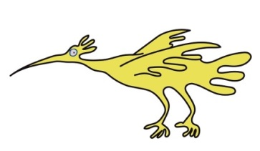

**Activities**

* **Things that go together**

Have 3 pictures of objects; find 2 that go together and explain why. Then think of 2 more items for that category.

* For example, house, apple, crisps. *Apple and crisps go together because they are food. 2 more are banana and pizza.*
* **Odd one out**

From 3 pictures, identify the odd one out and explain why.

* For example, car, bus, house. *House is the odd one out because you don’t drive it.*
* **Pass the object**

Pass an object between the adult and child.

The adult and child take turns to give an attribute (description) of the object.

* + For example, passing a spoon. *It is metal. It is shiny. It is for eating with. It is smooth. You can eat soup with it. They come in different sizes.*

Consider: What does it look like? Big/little, long/short, colour

What does it feel like? Heavy/light, smooth/bumpy,

What is it made of? Plastic, wood, metal

What is it used for? Eating, cutting, playing

* **Object in a box**
* A mystery object is placed in a box.
* The children take turns to ask a question about it in order to guess what it is.
* Encourage the children to ask relevant and informative questions and to remember previous clues. (If the child has difficulties remembering what has previously been said, help the child to remember, e.g. “*it is blue, it is round, you kick it*, what’s your question?”).
* Give models of appropriate questions e.g. *is it round/hard/red? Can you eat it? Is it alive?*
* **Lotto Game**
* Each child has a lotto board.
* Make sure the children can identify the pictures. (as them to find the picture when you name it, asking “show me the cup”)
* The adult can then give clues for each picture and the children can guess which picture it is (e.g. It’s round and you play with it (BALL)).
* Then the children can take turns at giving the clues.
* **Semantic Links**
* ****Write/draw the target word in a circle in the centre of a piece of paper.
* Draw a series of smaller circles around, connected to the centre by lines (like the word wheel below).
* Pupil thinks of associated items (for example, target word: car. Associated words: wheel, drive, shops, garage, car seat
* **Alternatives**
* Play games where you and the child identify an item and then have to think of an alternative word to describe/name it.

E.g. Aeroplane – jet

Jumper – hoodie

Pyjamas – bedclothes

* Similarly the child can think of things that go together e.g. “you say Toothbrush and …” and the child gives the second item

Schools can find further advice and ideas in the Primary School Toolkit: share appropriate ideas and advice with the child’s Parents/Carers so they can support the child at home too.

Sefton (0151 247 6109) Liverpool (0151 295 3990)

[**Childrensslt@alderhey.nhs.uk**](mailto:Childrensslt@alderhey.nhs.uk)

[Speech and language therapy - Alder Hey Children's Hospital Trust](https://www.alderhey.nhs.uk/services/speech-and-language-therapy/)

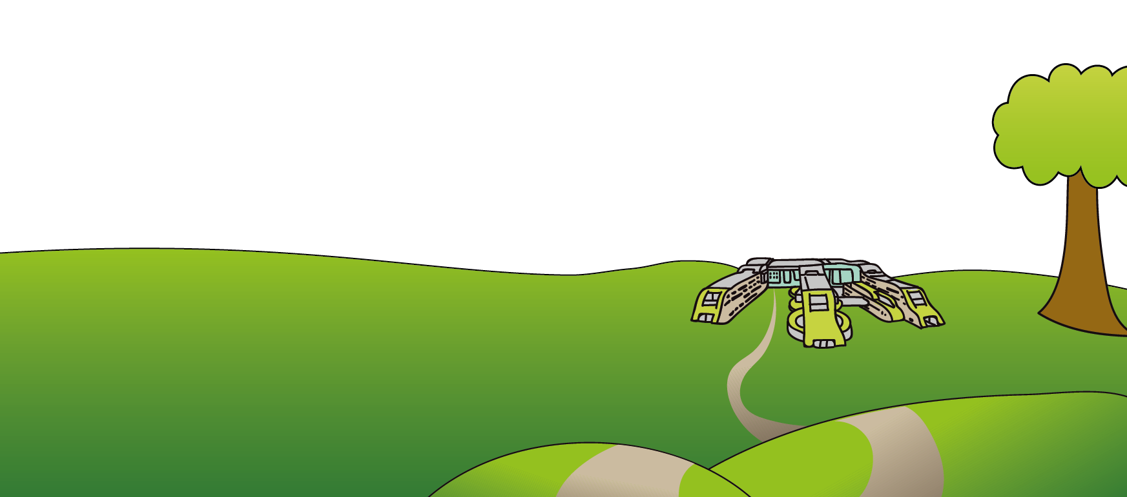

This leaflet only gives general information. You must always discuss the individual treatment of your child with the appropriate member of staff. Do not rely on this leaflet alone for information about your child’s treatment.

This information can be made available in other languages and formats if requested.

Alder Hey Children’s NHS Foundation Trust

Alder Hey

Eaton Road

Liverpool

L12 2AP

Tel: 0151 228 4811

[www.alderhey.nhs.uk](http://www.alderhey.nhs.uk)**© Alder Hey Review Date: PIAG:**

Word Wheel

