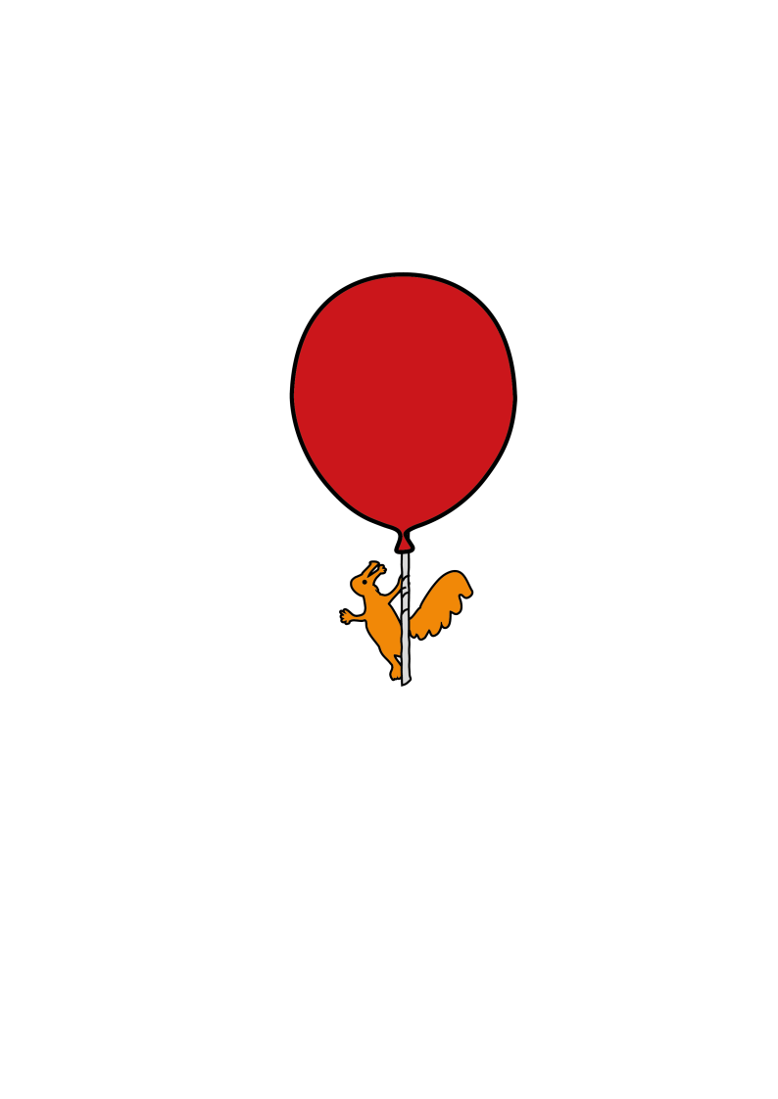

Community Speech and Language Therapy

**Activities and strategies to support Word Finding**

**Advice for parents/carers and settings for children with word finding difficulties (older KS2 and secondary)**

**Introduction**

Word finding difficulties occur when a child knows what they want to say but cannot access the correct vocabulary. Sometimes they may:

* Take a bit longer to ‘find’ the word, so they may pause or add in a phrase such as “um, you know”.
* Describe the word e.g. “it’s a big white thing you put things in, in the kitchen, to keep them very cold…freezer”
* Not be able to retrieve the word at all, which is often very frustrating for them.
* Produce a word which is linked by its meaning (i.e. knife instead of fork) or linked by how it sounds (i.e. cork instead of fork). Or the child may produce vague, non-specific words such as thingy, something, somebody, it, etc.

Sometimes it can be difficult to identify when a child is experiencing word finding difficulties, as many children develop quite sophisticated coping strategies. It is often most useful to note down words that the child has struggled with to reinforce later. The activities below can also help to build up a child’s vocabulary. Pick from the activities below that are most suitable for the age and interests of the child.

**Activities**

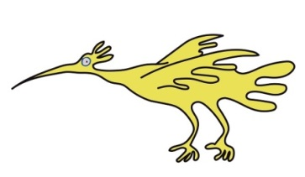

* **Things that go together**

From 3 pictures, find 2 that go together, explain why, and think of 2 more items for that category.

* **Odd one out**

From 3 pictures, identify the odd one out and explain why.

* **Semantic Links**
* Print target word in a circle in the centre of the worksheet.
* Draw a series of smaller circles around, connected to the centre by lines
* Pupil thinks of associated items
* Pupil draws a picture of the target word at the bottom of sheet.
* **Word Search Game** (Johnson, M 1994)
* Family – What group does it belong to? What object/words are from the same family?
* Function – What does it do? What do we do? Who?
* Time/Place – When? Where?
* Association – What else goes with it?
* Appearance – Size? Shape? What is it made of? Colour? Look? Parts? Sound? Smell? Texture? Age?
* Reaction – How do you feel about it?
* **What do you see?**
* Use either a simple line drawing or a non-complicated picture.
* ****Describe what you can see without showing the picture to the child.
* Ask the child to draw the same.
* Give the child a picture to describe to you. Encourage the child to give specific and appropriate information.

E.g. There is a house in the middle of the page

There is a big door on front of the house

There is a big tree on the left side, etc.

* **Alternatives**
* Play games where you and the child identify an item and then have to think of an alternative word to describe/name it.

E.g. Aeroplane – jet

Jumper – pullover

Pyjamas – bedclothes

* Similarly the child can think of things that go together e.g. “Toothbrush and …”

Schools can find further advice and ideas in the Primary School Toolkit: share appropriate ideas and advice with the child’s Parents/Carers so they can support the child at home too.

Sefton (0151 247 6109) Liverpool (0151 295 3990)

[**Childrensslt@alderhey.nhs.uk**](mailto:Childrensslt@alderhey.nhs.uk)

[Speech and language therapy - Alder Hey Children's Hospital Trust](https://www.alderhey.nhs.uk/services/speech-and-language-therapy/)

(click this link or type into search engine)

This leaflet only gives general information. You must always discuss the individual treatment of your child with the appropriate member of staff. Do not rely on this leaflet alone for information about your child’s treatment.

This information can be made available in other languages and formats if requested.

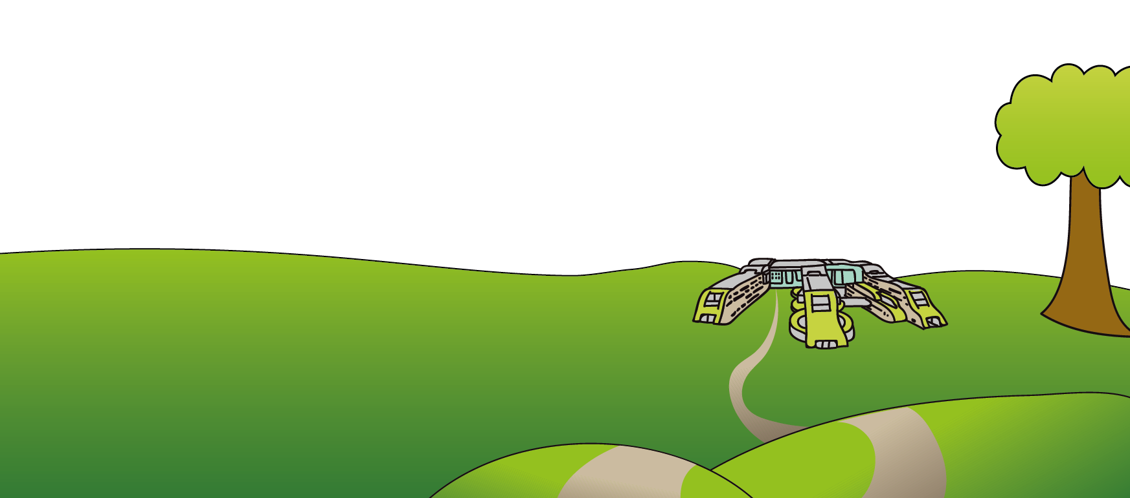

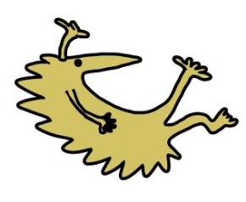Alder Hey Children’s NHS Foundation Trust

Alder Hey

Eaton Road

Liverpool

L12 2AP

Tel: 0151 228 4811

[www.alderhey.nhs.uk](http://www.alderhey.nhs.uk)

**Alder Hey Review Date: March 2028 PIAG: 596**

Word Wheel

