Title of study  Alder Hey Research MRI Application form | 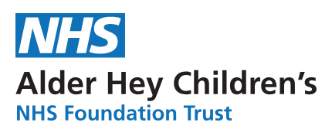
Name of applicant (s)

Contact number/email:

Recruiting Hospital/Department

Sponsor details: NHS/University or Pharma/Commercial

Study summary (200 words max)

Brief outline of methods/scanning schedule proposed (200 words max)

Start date of scanning

End date of scanning

Patient population

Patient Age range

Number of participants

Total number of scans required per patient
Total number of scans overall
Desired lead time between recruitment and scan
Funding available for MRI scans?

Funding available (if applicable)

Funding source

Ethics approval received.

Additional requirements? e.g. sedation, anaesthesia, contrast, patient preparation, reporting.

