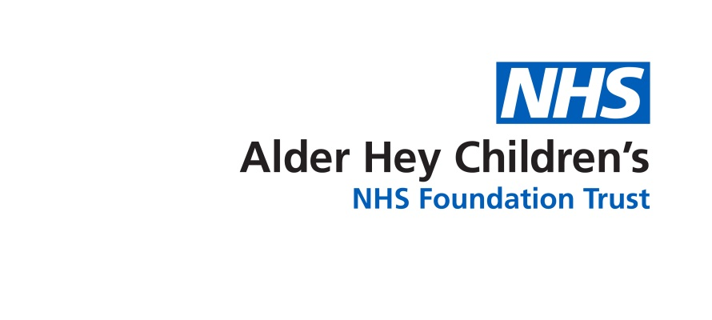

Community Speech and Language Therapy

Strategies to help understand children with unclear speech

Information for home and settings to help understand children who have unclear speech

When a child’s speech is difficult to understand there are lots of strategies to try that can help you understand more of what they are saying or give them alternative ways to get their message across:

* **Focus on what the child says** not how they say it (i.e. do you know what they mean rather than are the words clear, getting their message across is the most important aspect). Work out what they mean and respond without worrying about how the sounds are made
* If the child says words that are not clear **don’t correct them.** Instead ‘model’ the word back to them using the right speech sounds

**“My tar”**



**“Yes, your car!”**



* If the child’s speech is unclear, **encourage the use of gesture and actions** as well as asking them to take you to the things they want. Don’t pretend to understand them. Some children use gestures they have made up or use signs, this is helpful.
* **Get a list of relevant words** from the child’s family to give you some context as to what the child may be trying to say, for example family names, pet names, favourite toys and programmes

Consider if home/setting communication about what they have been doing would help, for example if you know they have been in the paddling pool over the weekend you have some context to help you work out their message (for example via a written diary or online communication systems)

Some schools and nurseries have used stickers printed (or written on) with “ask me about….” and then added on something to chat about at home, for example “ask me about … playing in the mud kitchen” to stick on the child’s jumper for home time.

* The more time you can spend listening to a child with unclear speech the more tuned in you get and the easier you may find it to understand them
* Try and use all possible opportunities to boost the child’s confidence, this may be through activities that do or do not involve talking
* Do everything you can to increase your chances of understanding – reduce background noise where you can, get down to the child’s level so you can listen, use context to help you work out what the child means
* Support the child’s confidence to interact and talk one to one, in small groups and in larger groups. They may be confident to talk in all these situations or may need support and a different way to send a message such as using gesture or showing an object or picture
* **Don’t make the child repeat words, just repeat it back to them correctly.** Drawing attention to mispronunciations and making the child repeat words is not helpful (if they are happy to repeat their message to help you understand that is fine)



**DON’T SAY**

“It’s not tar say car!

Say it again…C-AR!”

**YOU SHOULD SAY**

“Yes…your car, big car,

fast car”



* Don’t correct the child’s speech – they probably think they are saying the word correctly. The child may be able to say a sound on its own but not in words e.g. they may be able to say ‘ssss’ but still say ‘**d**ock’ for sock

Look at[speech-sounds-factsheet.pdf (speechandlanguage.org.uk)](https://speechandlanguage.org.uk/media/3293/speech-sounds-factsheet.pdf) and [What age do speech sounds develop? Questions to help young children learn to pronounce words - BBC Tiny Happy People](https://www.bbc.co.uk/tiny-happy-people/speech-sound-phonic-development/z3ybg7h) for more information on speech sound development

References: Henrietta McLachlan and Liz Elks (2007) ‘Let’s Talk with Under 5s’

**Alder Hey Community Speech and Language Therapy Department**

**Sefton (0151 247 6109) Liverpool (0151 295 3990)**

[**Childrensslt@alderhey.nhs.uk**](mailto:Childrensslt@alderhey.nhs.uk)

[Speech and language therapy - Alder Hey Children's Hospital Trust](https://www.alderhey.nhs.uk/services/speech-and-language-therapy/)

(click this link or type into search engine)

This leaflet only gives general information. You must always discuss the individual treatment of your child with the appropriate member of staff. Do not rely on this leaflet alone for information about your child’s treatment.

This information can be made available in other languages and formats if requested.

Alder Hey Children’s NHS Foundation Trust

Alder Hey

Eaton Road

Liverpool

L12 2AP

Tel: 0151 228 4811

[www.alderhey.nhs.uk](http://www.alderhey.nhs.uk)

**© Alder Hey Review Date: March 2028 PIAG: 607**